GFMI dq Admittance Extraction Using a Raised-Cosine Pulse

1. Objective
The aim of this investigation was to determine whether a broadband raised-cosine pulse could be used to identify the low-frequency $2×2$dq admittance matrix of a grid-forming inverter more efficiently than conventional single-tone frequency scanning.
The dq admittance matrix is
$$\left[\begin{matrix}ΔI_{d} \\ ΔI_{q}\end{matrix}\right]=\left[\begin{matrix}Y_{dd} & Y_{dq} \\ Y_{qd} & Y_{qq}\end{matrix}\right]\left[\begin{matrix}ΔV_{d} \\ ΔV_{q}\end{matrix}\right].$$
A complete dq matrix requires two independent perturbations:
- A d-axis voltage-magnitude perturbation.
- A q-axis phase-angle perturbation.
The proposed method therefore uses one raised-cosine d-axis pulse simulation and one raised-cosine q-axis pulse simulation. The two responses are combined in the frequency domain to calculate the complete admittance matrix over multiple frequencies.
The main research questions were:
- Can two broadband pulse simulations replace multiple d-axis and q-axis sinusoidal scans?
- Over what frequency range does the pulse method agree with dedicated single-tone reference simulations?
- Under what conditions does the pulse method fail?
- Is the result sensitive to pulse amplitude, repeated simulation, record length, FFT processing or insufficient excitation energy?
- What practical improvements are needed before applying the method to switching-model or measured data?
The validated average GFMI was used for the controlled investigation. So the pulse-processing method was investigated without PWM switching ripple obscuring the underlying behaviour.

2. Raised-Cosine Pulse
The raised-cosine pulse was selected because it changes smoothly at its beginning and end. Compared with a rectangular pulse, the gradual transition reduces sharp discontinuities and limits spectral leakage.
The pulse can be expressed as
$$p\left(t\right)=\frac{A}{2}\left[1-\cos\left(2πf_{w}\left(t-t_{s}\right)\right)\right],$$
during the pulse interval, where:
- A is the pulse amplitude,
- F_{w} is the raised-cosine frequency parameter,
- T_{s} is the pulse start time.
The pulse is zero outside the selected interval.
For the d-axis test, the pulse was added to the voltage-magnitude command:
$$V_{\text{source,perturbed}}=V_{\text{source}}\left(1+ΔV_{d,\text{pulse}}\right).$$
For the q-axis test, the pulse was added to the source phase angle:
$$ϕ_{\text{perturbed}}=ϕ_{0}+Δϕ_{\text{pulse}}.$$
Only one perturbation was enabled in each simulation.

3. Model and Operating Point
The tests were performed using the validated average GFMI model.
Before applying any perturbation, the model was run until it reached its normal steady operating point. The displayed steady-state quantities were approximately:
Quantity | Steady-state value
Active power, $P$ | 2 pu
Reactive power, $Q$ | −0.2205 pu
Voltage magnitude, $V$ | 0.6768 pu
All pulse, reduced-amplitude, repeated, and single-tone simulations used the same model parameters and operating point.
Maintaining the same operating point is essential because inverter admittance depends on the operating condition. Pulse and single-tone results obtained at different active power, reactive power or terminal voltage cannot be directly compared.

4. Simulation Parameters
Parameter | Value
Model | Validated average GFMI
Nominal frequency | 50 Hz
Simulation duration | 24 s
PSCAD solution timestep | 50 µs
Output/plot timestep | 50 µs
Sampling frequency | 20 kHz
Pulse start time | 5 s
Pulse width | 0.5 s
Raised-cosine parameter, $f_{w}$ | 2 Hz
Main d-axis amplitude | 0.005 pu
Main q-axis amplitude | 0.5°
Half d-axis amplitude | 0.0025 pu
Half q-axis amplitude | 0.25°
Settled baseline interval | 4.0–4.9 s
FFT interval | 4.0–24.0 s
FFT duration | 20 s
Frequency resolution | 0.05 Hz
Minimum number of cycles | 5
Energy threshold | −40 dB
Condition-number limit | 10
Reference acceptance threshold | 10%
Screening threshold | 20%
Linearity threshold | 10%
The single-tone reference simulations were conducted at $0.5, 1, 2, 3, \text{and }5\text{ Hz}.$
Each frequency required one d-axis and one q-axis simulation.

5. Data Processing

5.1 abc-to-dq transformation
The measured three-phase PCC voltages and currents were converted into stationary $αβ$ quantities using a power-invariant transformation:
$$α=\sqrt{\frac{2}{3}}\left(a-\frac{1}{2}b-\frac{1}{2}c\right), \\ β=\sqrt{\frac{2}{3}}\left(\frac{\sqrt{3}}{2}b-\frac{\sqrt{3}}{2}c\right).$$
The dq reference angle was estimated from the fundamental positive-sequence PCC voltage during the settled 4.0–4.9 s interval.
The transformation was then performed using
$$d=α\cos{θ}+β\sin{θ}, \\ q=-α\sin{θ}+β\cos{θ}.$$
The final calculated offsets were:
- d-axis run offset = 0.207075 rad
- q-axis run offset = 0.207075 rad
- Difference = 0 rad
The zero offset difference confirms that the d- and q-axis pulse results were expressed in consistent dq reference frames.

5.2 Baseline subtraction
The mean dq voltage and current values calculated over 4.0–4.9 s were subtracted from each waveform.
This removed the steady component and retained only the incremental response caused by the perturbation.
The final response diagnostics were:
- Pre-pulse current variation = 1.968×10⁻⁴
- Late current variation = 1.695×10⁻⁴
- Decay check = Passed
These values confirm that the system had settled before the pulse and had returned close to its normal steady variation by the end of the record.

5.3 Frequency-domain extraction
The incremental dq quantities were transformed into the frequency domain.
For each frequency,
$$V\left(f\right)=\left[\begin{matrix}V_{d,d}\left(f\right) & V_{d,q}\left(f\right) \\ V_{q,d}\left(f\right) & V_{q,q}\left(f\right)\end{matrix}\right], \\ I\left(f\right)=\left[\begin{matrix}I_{d,d}\left(f\right) & I_{d,q}\left(f\right) \\ I_{q,d}\left(f\right) & I_{q,q}\left(f\right)\end{matrix}\right].$$
The admittance matrix was then calculated using
$$Y\left(f\right)=I\left(f\right)V^{-1}\left(f\right).$$
In MATLAB, this was implemented using right matrix division:
Y = I/V;

6. FFT-Window Investigation
An important finding was that simply increasing the simulation duration did not automatically improve accuracy.
Initially, a baseline interval of 0.5–1.9 s and a Hann-windowed FFT interval of 2–24 s were used. However, the average GFMI was still settling during the early baseline interval.
This produced:
- dq offset = 0.126232 rad
- Pre-pulse variation = 1.751
- Late variation = 1.169
The early interval therefore did not represent the final operating point.
The Hann window also reduced the contribution of the raised-cosine pulse because the pulse occurred at 5 s, away from the centre of the 2–24 s window.
After changing to:
- A settled baseline interval of 4.0–4.9 s,
- A 4–24 s FFT interval,
- A rectangular FFT window,
the low-frequency agreement improved substantially.
Frequency | Initial full-matrix error | Corrected full-matrix error
0.5 Hz | 14.63% | 1.91%
1 Hz | 12.79% | 1.17%
2 Hz | 8.63% | 0.96%
3 Hz | 6.00% | 2.11%
5 Hz | 3.53% | 7.95%
The corrected processing was retained because it excluded the startup transient, used a settled operating-point baseline and aligned the validation frequencies exactly with the 0.05 Hz FFT grid.
This demonstrates that broadband transient identification is sensitive not only to record length, but also to baseline selection, transient position and window weighting.

7. Broadband Bin Qualification
A frequency bin was not retained only because MATLAB produced a numerical value. Three independent requirements were applied.

7.1 Minimum-cycle requirement
The number of cycles in the 20 s FFT interval was calculated as
$$N_{\text{cycles}}=fT_{\text{FFT}}.$$
At least five cycles were required:
$$fT_{\text{FFT}}≥5.$$
For a 20 s interval,
$$f_{min}=\frac{5}{20}=0.25\text{ Hz}.$$
Frequencies below 0.25 Hz were rejected.

7.2 Excitation-energy requirement
Both the d- and q-axis perturbations were required to contain sufficient spectral energy.
A −40 dB relative energy threshold was used. Bins with insufficient pulse energy were rejected because dividing by a weak input spectrum can strongly amplify numerical error.

7.3 Matrix-conditioning requirement
The condition number of the voltage perturbation matrix was calculated at each frequency, $κ\left(V\right)=\text{cond}\left(V\right).$
Only bins satisfying $κ\left(V\right)<10$ were retained.

7.4 Qualification results
For the main full-amplitude pulse:
Qualification test | Result
Total evaluated bins | 399
Energy-qualified bins | 95
Condition-qualified bins | 380
Cycle-qualified bins | 396
Final numerically qualified bins | 92
Numerically qualified percentage | 23.1%
The 92 qualified bins formed two non-continuous bands:
Qualified band | Number of bins
0.25–3.80 Hz | 72
4.30–5.25 Hz | 20

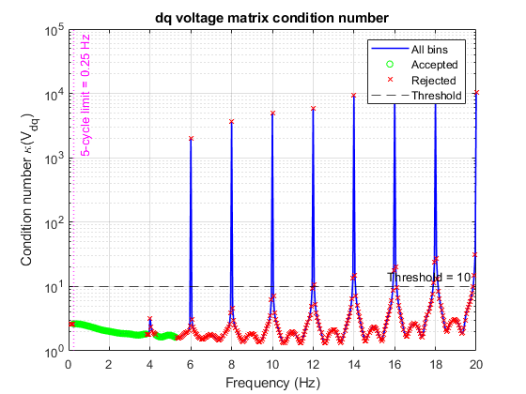
Figure 1 - Broadband frequency-bin qualification based on excitation energy, voltage-matrix conditioning and minimum-cycle requirements.

8. dq Admittance Magnitude and Phase
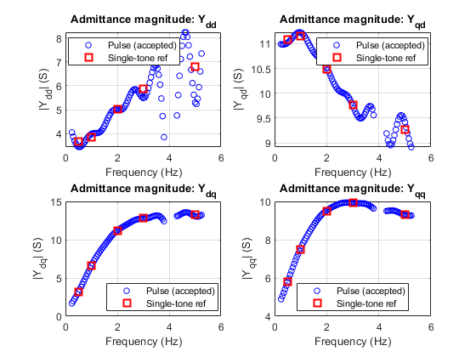
Figure 2 - Magnitudes of the four pulse-derived dq-admittance elements compared with the dedicated single-tone reference results.
The pulse-derived admittance curves were smooth throughout most of the first qualified band. The single-tone reference markers at 0.5, 1, 2 and 3 Hz followed the pulse-derived responses closely.
The second qualified band extended from 4.30 to 5.25 Hz. However, numerical qualification alone did not guarantee elementwise accuracy. The 5 Hz validation later showed that $Y_{dd}$was unreliable even though the frequency passed the energy, cycle and condition-number checks.
This indicates that energy and conditioning are necessary screening criteria, but they are not sufficient substitutes for independent accuracy validation.
The phase trends were generally smooth. However, magnitude and phase plots were not used alone to classify the results. The final decision used complex error, which includes both magnitude and phase differences.

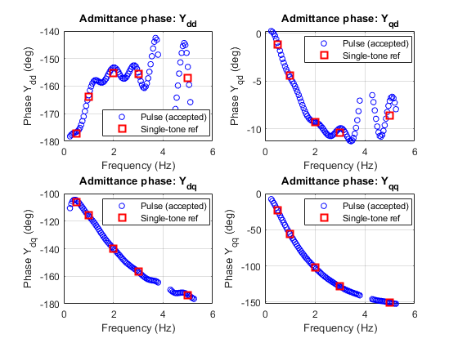
Figure 3 - Phases of the four pulse-derived dq-admittance elements compared with the dedicated single-tone reference results.

8.1 Pulse versus Rezonance Admittance Comparison
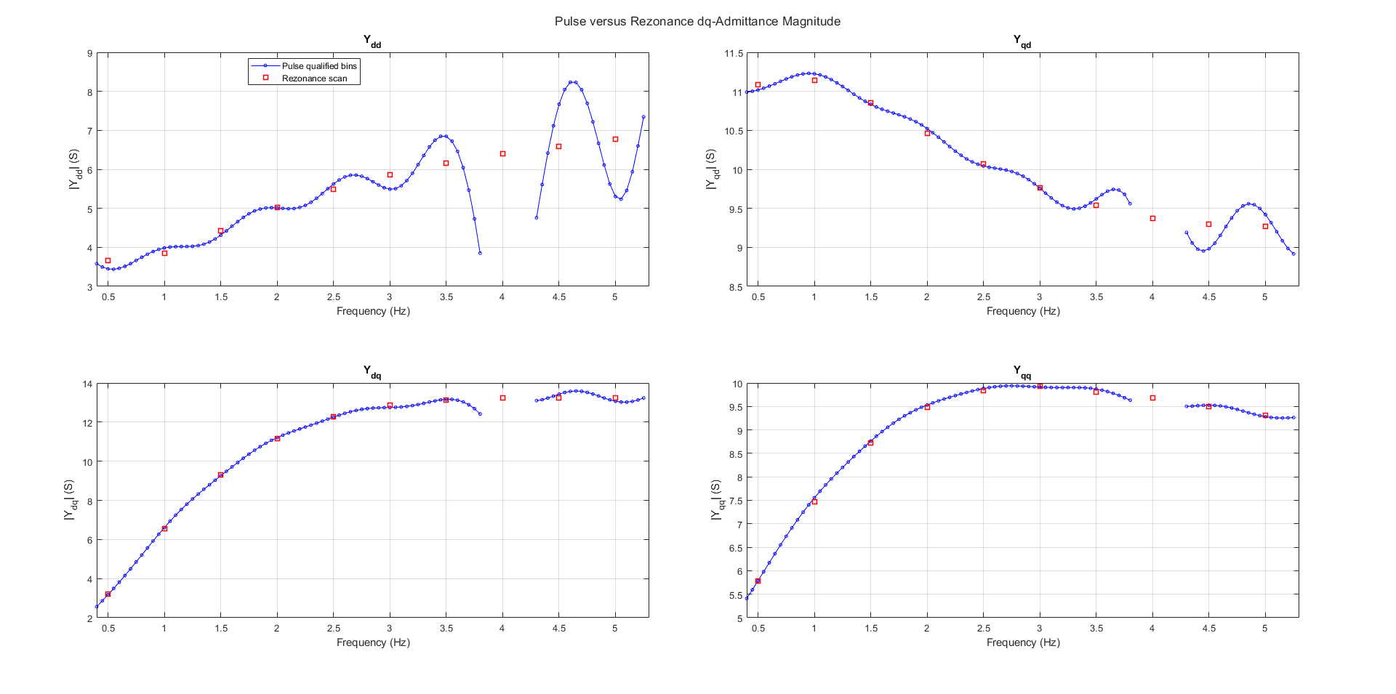
Figure 4 - Comparison of pulse-derived and Rezonance dq-admittance magnitudes over the common frequency range.
The Rezonance scan was included as an additional independent reference after applying the required per-unit scaling and current-direction conversion. The pulse and Rezonance results showed close full-matrix agreement, with errors of 1.23%, 1.16% and 2.39% at 1, 2 and 3 Hz, respectively. At 5 Hz, the full-matrix error was 8.00%. However, the $Y_{dd}$element error was 22.51%, confirming the failure already identified using the dedicated single-tone and linearity tests. Therefore, the Rezonance comparison supports validation of the complete pulse-derived matrix from 1–3 Hz but does not support complete-matrix validation at 5 Hz.

9. Comparison with Single-Tone References
The complex relative error was calculated using
$$E_{Y}\left(f\right)=\frac{∣Y_{\text{pulse}}\left(f\right)-Y_{\text{reference}}\left(f\right)∣}{∣Y_{\text{reference}}\left(f\right)∣}×100\%.$$
The classification criteria were:
Complex error | Classification
$$E_{Y}≤10\%$$ | Accepted
$$10\%<E_{Y}≤20\%$$ | Screening only
$$E_{Y}>20\%$$ | Rejected

9.1 Elementwise results
Frequency | $$Y_{dd}$$ | $$Y_{qd}$$ | $$Y_{dq}$$ | $$Y_{qq}$$ | Full-matrix decision
0.5 Hz | 6.43% | 0.62% | 2.16% | 0.11% | Accepted
1 Hz | 3.46% | 0.69% | 1.14% | 0.78% | Accepted
2 Hz | 3.36% | 0.42% | 0.30% | 0.34% | Accepted
3 Hz | 6.64% | 0.75% | 1.05% | 0.17% | Accepted
5 Hz | 22.65% | 3.22% | 1.48% | 0.50% | Partially rejected

9.2 Full-matrix errors
Frequency | Full-matrix complex error
0.5 Hz | 1.91%
1 Hz | 1.17%
2 Hz | 0.96%
3 Hz | 2.11%
5 Hz | 7.95%
Although the overall matrix error at 5 Hz was below 10%, $Y_{dd}$exceeded the elementwise rejection threshold. Therefore, the complete matrix was not classified as validated at 5 Hz.
This elementwise assessment prevents a large error in one relatively small matrix element from being hidden by the norm of larger elements.
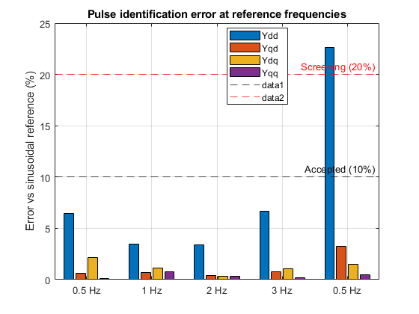
Figure 5 - Elementwise complex relative errors between the pulse-derived admittance and dedicated single-tone references. The dashed lines indicate the 10% acceptance and 20% rejection thresholds.

10. Linearity Test
Admittance is a small-signal quantity. If the pulse amplitude is sufficiently small, reducing it by half should produce approximately the same identified admittance.
The amplitude-sensitivity metric was
$$E_{\text{lin}}\left(f\right)=\frac{∣Y_{\text{half}}\left(f\right)-Y_{\text{full}}\left(f\right)∣}{∣Y_{\text{full}}\left(f\right)∣}×100\%.$$
A 10% threshold was applied.

Frequency | $$Y_{dd}$$ | $$Y_{qd}$$ | $$Y_{dq}$$ | $$Y_{qq}$$
0.5 Hz | 6.23% | 0.90% | 2.80% | 0.85%
1 Hz | 4.03% | 0.45% | 0.73% | 0.09%
2 Hz | 3.42% | 0.55% | 0.66% | 0.28%
3 Hz | 6.36% | 1.00% | 0.73% | 0.31%
5 Hz | 28.51% | 3.00% | 2.10% | 0.51%
All elements passed the linearity test from 0.5 to 3 Hz.
At 5 Hz, $Y_{dd}$changed by 28.51% and failed the linearity criterion. This agrees with the 22.65% single-tone reference error at the same frequency.
Because $Y_{dd}$failed two independent checks at 5 Hz, its failure cannot be treated as an isolated comparison error.
Possible causes include:
- Reduced effective pulse energy for that element,
- Greater sensitivity of the d-axis response at the upper end of the pulse bandwidth,
- Numerical cancellation,
- Amplitude-dependent inverter response,
- Remaining transient-extraction sensitivity.
The current tests cannot completely separate physical nonlinearity from extraction sensitivity. Therefore, the conservative decision is to reject the 5 Hz $Y_{dd}$estimate.
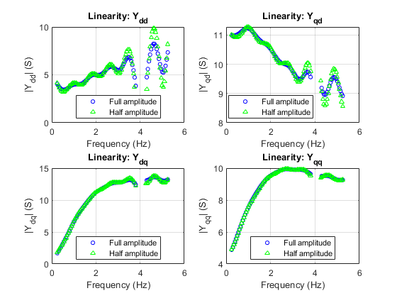
Figure 6 - Linearity assessment based on the difference between the admittance estimates obtained using full- and half-amplitude pulses.

11. Repeatability
The full-amplitude d- and q-axis pulse simulations were repeated using identical settings.
The original and repeated CSV files were found to be byte-for-byte identical.
The frequency-domain comparison gave:
Repeatability measure | Result
Original qualified bins | 92
Repeated qualified bins | 92
Common bins | 92
Bin agreement | 100%
Median error, all elements | 0%
95th-percentile error, all elements | 0%
Maximum error, all elements | 0%
This confirms that the average-model pulse simulations and MATLAB processing are numerically reproducible.
However, exact repeatability should not be interpreted as proof of immunity to practical noise. The average model is deterministic and does not include random measurement noise or PWM switching variability.
Therefore, this test confirms computational reproducibility under identical conditions, rather than experimental robustness.

12. Runtime and Scan Reduction
The production pulse-identification method requires:
- One full-amplitude d-axis pulse simulation.
- One full-amplitude q-axis pulse simulation.
The 92 numerically qualified bins would require:
$$92×2=184$$
single-tone simulations if every frequency were scanned individually.
The projected run-count reduction is therefore
$$\frac{184}{2}=92.$$
Thus, the broadband method requires 92 times fewer production simulations than a complete d/q single-tone scan over the same qualified bins.
This value is a projected run-count reduction, not a directly measured runtime speed-up.
Measured runtime table
Case | PSCAD runtime
Full d-axis pulse | 6.46 s
Full q-axis pulse | 5.86 s
Main two-pulse total | 12.32 s
MATLAB pulse processing | 1.533 s
Total production pulse time | 13.853 s
For the five selected validation frequencies:

Frequency | d-axis runtime | q-axis runtime | Total
0.5 Hz | 6.56 s | 6.78 s | 13.34 s
1 Hz | 6.61 s | 6.88 s | 13.49 s
2 Hz | 6.50 s | 6.81 s | 13.31 s
3 Hz | 6.48 s | 6.81 s | 13.29 s
5 Hz | 6.54 s | 6.82 s | 13.36 s

The two pulse simulations produced 92 qualified frequency points, whereas a conventional single-tone scan would require separate d- and q-axis simulations at each frequency, giving 184 simulations. The ten measured single-tone validation simulations required 66.79 s, corresponding to an average of 6.679 s per simulation. Therefore, an equivalent conventional scan is estimated to require 1228.94 s. The complete pulse workflow, including PSCAD simulations and MATLAB processing, required 13.853 s, giving an estimated equal-resolution acceleration of approximately 88.7×.
$$T_{conventional}=2\left(92\right)\left(\frac{66.79}{10}\right)=1228.94 s$$Estimated acceleration=1228.94​/ 13.853 =88.71

13. Main Research Findings

13.1 Record length alone is not sufficient
Increasing the record length increased the number of available low-frequency cycles. However, using an unsettled baseline and an unsuitable time weighting still produced large errors.
A longer simulation only improves identification when:
- The baseline represents the final operating point,
- The pulse is positioned appropriately within the record,
- The response has sufficiently decayed,
- The analysis window does not introduce excessive bias.

13.2 Numerical qualification is not the same as validation
The energy, conditioning and cycle tests identified frequencies where matrix calculation was numerically possible. They did not guarantee physical accuracy.
At 5 Hz, the bin passed all numerical qualification tests, but $Y_{dd}$failed both reference accuracy and linearity.
Therefore, qualified bins should initially be treated as screening estimates until selected reference tests confirm their accuracy.

13.3 Different matrix elements have different sensitivity
The off-diagonal and q-axis-related terms remained accurate at 5 Hz, while $Y_{dd}$failed.
This shows that it is unsafe to validate a complete matrix using only a single overall matrix norm. Elementwise validation is required because one element can fail while the others remain accurate.

13.4 A practical operating range was identified
For the tested model and pulse parameters:
- The complete matrix was validated at selected frequencies from 0.5 to 3 Hz.
- Frequencies from 0.25 to 0.45 Hz were numerically qualified but not independently validated.
- The band from 4.30 to 5.25 Hz was numerically qualified, but the complete matrix failed at 5 Hz because of $Y_{dd}$.
- Frequencies above approximately 5.25 Hz did not contain sufficient qualified pulse energy.
The validated range applies to this model, operating point and pulse configuration. It should not be treated as a universal limit for all GFMIs.

14. Failure Conditions
The investigation identified the following conditions under which raised-cosine pulse identification may become unreliable.

14.1 Unsettled baseline
If the baseline interval is selected before the system reaches steady state, the calculated dq offset and incremental waveforms become biased.

14.2 Insufficient cycles
Low-frequency estimates become unreliable when the observation window contains too few cycles. A minimum of five cycles was used in this investigation.

14.3 Insufficient excitation energy
At frequencies where the pulse spectrum is weak, voltage-matrix inversion amplifies noise and numerical error.

14.4 Poor matrix conditioning
If the d- and q-axis voltage perturbations do not provide sufficiently independent excitation, the voltage matrix becomes poorly conditioned.

14.5 Pulse-amplitude sensitivity
If full- and half-amplitude pulses produce substantially different admittance values, the result may not represent a reliable small-signal quantity.

14.6 Inappropriate FFT window
Window functions can bias transient broadband identification when the pulse and response occur in a low-weight part of the window.

14.7 Incomplete elementwise validation
A small full-matrix error can hide a large error in one element. Each matrix element must therefore be checked separately.

14.8 Operating-point mismatch
Pulse and reference simulations must use the same active power, reactive power and voltage operating point.

14.9 Switching ripple and measurement noise
The main investigation used a deterministic average model. A switching model or experimental measurement may require filtering, averaging or spectral estimation methods to manage PWM ripple and noise.

15. Possible Improvements
The following changes could improve or extend the method.
- Automatically detect when the system has settled instead of manually selecting the baseline interval.
- Select the FFT window using the measured pulse and decay times.
- Use an adaptive energy threshold based on the noise floor rather than a fixed −40 dB value.
- Use several pulse amplitudes to distinguish physical nonlinearity from numerical sensitivity.
- Use a shorter pulse or modified pulse shape to extend the excitation bandwidth above 5 Hz.
- Use multiple differently shaped pulses or a multisine input to fill spectral gaps.
- Add uncertainty bounds to each matrix element.
- Repeat the test with added measurement noise.
- Validate selected results using a matched switching-model operating point.
- Develop element-specific acceptance criteria, since $Y_{dd}$was more sensitive than the other matrix elements.
These improvements represent future research directions rather than requirements for the current validation.

16. Final Conclusion
The raised-cosine pulse method successfully identified the low-frequency dq admittance of the validated average GFMI using only two production pulse simulations.
After correcting the baseline and FFT processing, the pulse-derived complete dq matrix agreed with dedicated single-tone references at 0.5, 1, 2 and 3 Hz. All elementwise complex errors were below 10%, while full-matrix errors ranged from 0.96% to 2.11%.
The results were also linear with respect to pulse amplitude and exactly repeatable in the deterministic average model.
The method was not fully valid at 5 Hz. Although three matrix elements remained accurate, $Y_{dd}$showed a 22.65% reference error and a 28.51% amplitude sensitivity. Frequencies above approximately 5.25 Hz also failed the pulse-energy requirement.
Therefore, for the tested model, operating point and pulse parameters, the recommended fully validated range is 0.5–5 Hz at the selected validation frequencies.
The main research conclusion is that broadband pulse identification can significantly reduce the number of simulations, but its output must be screened using minimum-cycle, excitation-energy, conditioning, elementwise reference and amplitude-linearity criteria. A smooth admittance curve or numerically invertible voltage matrix alone is not sufficient evidence of accuracy.
The method provides a useful rapid screening tool for low-frequency inverter admittance, while dedicated single-tone scans remain necessary for selected validation points and frequencies near the usable-bandwidth boundary.

